

**YEAR: 7**

**2019**

**SUBJECT: Science**

**TEST: Classification**

**TIME: 50 minutes**

**QUESTIONS: 10 Multiple Choice (10 marks)**

**8 Short Answer (31 marks)**

**TOTAL MARKS: 41 marks**

**DO NOT WRITE ON OR MARK THIS PAPER**

**Part A: Multiple Choice Questions (10 marks)**

**Indicate Answer on Answer Sheet.**

1) State the type of scientist who names and classifies things.

a. Ecologist

b. Biologist

c. Taxonomist

d.Zoologist

2) Scientists classify organisms because:

a. it makes it easier to identify organisms.

b. there are only a few organisms that differ from each other.

c. most discoveries in biology have already been made.

d. all organisms have characteristics in common.

3) Organisms can be grouped into five major kingdoms. These are:

a. mammals, fish, birds, amphibians and reptiles.

b. animals, fungi, monera, plants and protists.

c. animals, fungi, insects, plants and algae.

d. animals, plants, insects, birds and reptiles.

4) Kingdoms themselves can be sub-divided. The sequence of classification following kingdoms is:

a. species, phylum, class, order, family, genus.

b. class, order, family, genus, species, phylum.

c. order, family, genus, phylum, class, species.

d. phylum, class, order, family, genus, species.

5) A vertebrate is an animal which has:

a. a backbone.

b. a hard shell.

c. wings.

d. fins

6) The reason for using structural characteristics (rather than colour or size) for classification is:

a. structural features are easy to observe.

b. individuals of the same type can differ in colour.

c. organisms change size as they grow.

d. all of the above.

**The diagram shows four characters, and a key to identify them.**

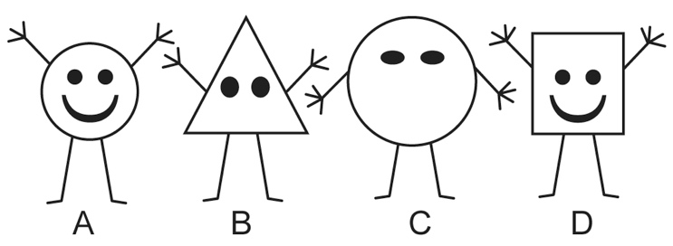

1 Round body Go to 3.

Not round body Go to 2.

2 Three fingers Gertie

Four fingers Iris

3 Mouth Fred

No mouth Harry

7) Which one is Iris?

a. A

b. B

c. C

d. D

8) Use the circular key below to **classify** an animal with 6 legs, 4 heads, 8 eyes and no mouth.

1. 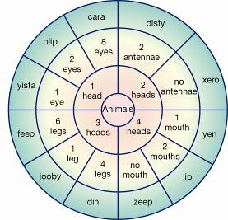
2. a. Feep
3. b. Xero
4. c. Cara
5. d. Zeep

9) Look at the four sea animals below:

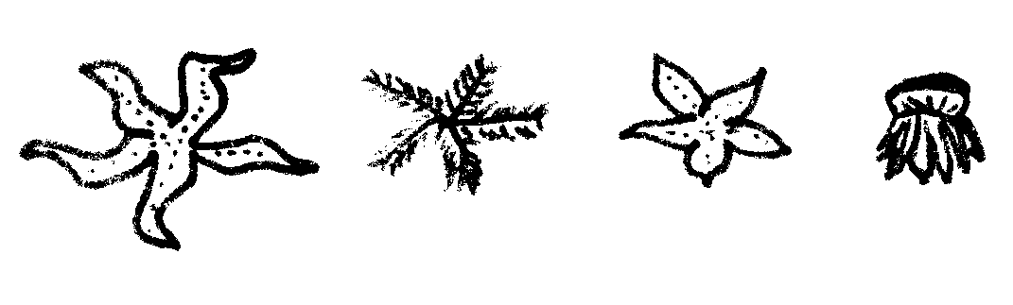

D

C

B

A

If three (3) of these animals were to be placed in one group and the remaining one in a separate group, which one would be in a group by itself?

1. A
2. B
3. C
4. D

10) Students created this key for their group.

1a Male Go to 2

b Female Go to 5

2a Straight hair Go to 3

b Curly hair Go to 4

3a Can roll tongue Mark

b Cannot roll tongue Yasu

4a Brown eyes Hans

b Grey eyes Jack

5a Straight hair Jane

b Curly hair Mai

**Identify** the description of Jack.

a) Straight-haired male with brown eyes that cannot role his tongue.

b) Curly-haired male with grey eyes.

c) Male that can roll his tongue and has grey eyes and curly hair.

d)Male with straight hair and brown eyes.



**SEMESTER TWO 2019**

**Classification Science Test:**

**ANSWER BOOKLET**

**NAME:**

**FORM:** **DATE:**

Multiple Choice Short Answer Total

**/31**

**/10**

**/41**

**SECTION ONE:** Multiple choice answers

Cross (X) through the correct answer.

|  |  |  |  |  |
| --- | --- | --- | --- | --- |
| **1** | a | b | c | d |
| **2** | a | b | c | d |
| **3** | a | b | c | d |
| **4** | a | b | c | d |
| **5** | a | b | c | d |
| **6** | a | b | c | d |
| **7** | a | b | c | d |
| **8** | a | b | c | d |
| **9** | a | b | c | d |
| **10** | a | b | c | d |

**ASSESSMENT KEY**

|  |  |
| --- | --- |
| **I CAN STATEMENTS** | **QUESTIONS** |
| **MUST**  Classifies organisms using observable similarities and differences and applying simple classification keys. | 1,2,3,4,5,10  11a,11bi,12,13,17 |
| **SHOULD**  Classifies organisms using observable similarities and differences, constructing and applying classification keys. | 6,7,8,9  11bii,14, 18 |
| **COULD**  Classifies unfamiliar organisms using observable similarities and differences, constructing and applying varied classification keys. | 15, 16 |

**Part B: Short Answer Questions (31 marks)**

**Answer in the spaces provided.**

1. Biologists use factors or criteria to determine whether something is living or non-living.

a) Using MR N GREWW, write down the 8 criteria that an object must satisfy to be considered living. (4 marks)

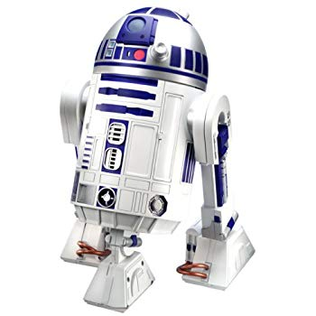  
M____________________________________________________________________________  
  
R_____________________________________________________________________________  
  
N_____________________________________________________________________________  
  
G_____________________________________________________________________________  
  
R_____________________________________________________________________________  
  
E_____________________________________________________________________________  
  
W____________________________________________________________________________  
  
W____________________________________________________________________________   
  
  
  
b) This is a picture of a robot.   
 Sammy thinks robots are a living thing.  
Bobby thinks the robots are a non-living thing.  
  
  
  
  
  
  
  
  
  
i) Who is correct? Bobby or Sammy? (1 mark)  
  
_________________________________________________________________________________________  
  
ii) Using MR N GREWW, explain your answer (2 marks)  
  
________________________________________________________________________________________________  
  
________________________________________________________________________________________________

12. To classify things, objects need to be compared to each other by looking at their similarities and differences. Below are two pictures. (2 marks)

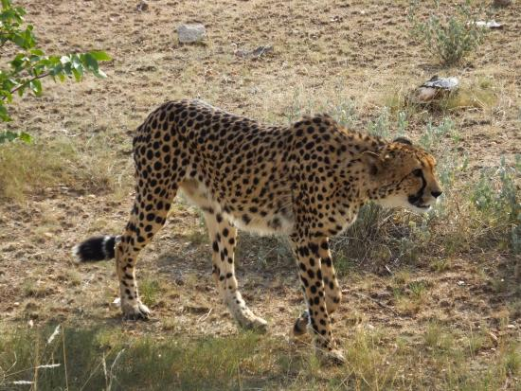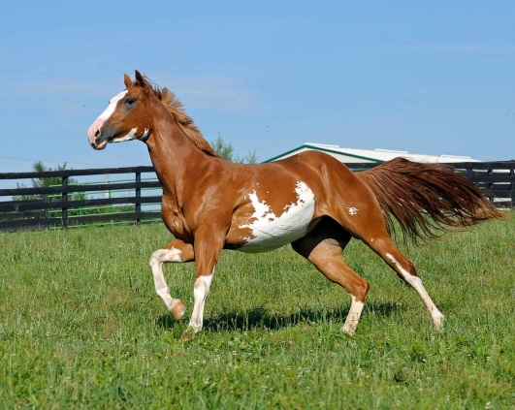

1. Write down 2 similarities between the animals above  
     
   ___________________________________________________________________________  
     
   ___________________________________________________________________________
2. Write down 2 differences between the animals above  
     
   ___________________________________________________________________________  
     
   ___________________________________________________________________________

13. We classify many things in everyday life, not just living things. (2 marks)  
  
a) State two reasons of using classifications  
  
____________________________________________________________________________________________________  
  
____________________________________________________________________________________________________  
  
____________________________________________________________________________________________________  
  
b) Can you name two places in everyday life that classification is used  
  
____________________________________________________________________________________________________  
  
____________________________________________________________________________________________________  
  
____________________________________________________________________________________________________

14. Use the key below to classify the animals pictured here. (4 marks)

**KEY**

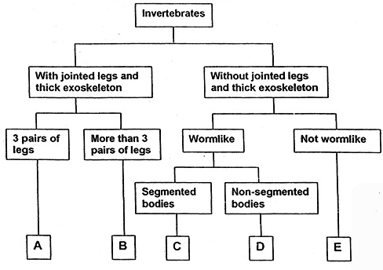

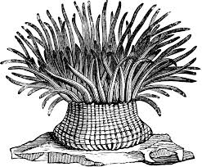**ANIMALS**

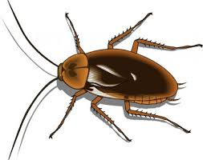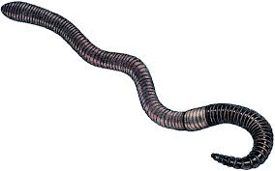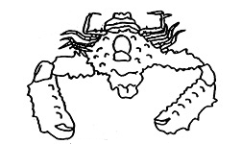

1 2 3 4

|  |  |
| --- | --- |
| **ANIMAL** | **GROUP (A,B,C,D or E)** |
| **1** |  |
| **2** |  |
| **3** |  |
| **4** |  |

15. Using the 3 creatures below, design a Dichotomous key (minimum of 3 steps)

to help identify them based on 2 or more specific characteristics. (3marks)

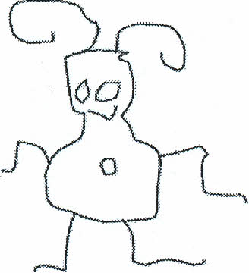

GLOP

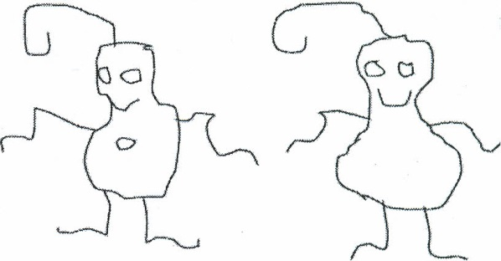

BIP

GLIP

16. Use the key to identify the name of each alien below. (5 marks)

**Alien Dichotomous Key**

1. A. Does the alien have feet?…………………………..Go to statement 2

B. Does the alien have no feet?……………………….Go to statement 7

2. A. Does the alien have socks?………………………..Go to statement 3

B. Does the alien have no socks?…………………….Go to statement 5

3. A. Does the alien have antennae?…………………….Go to statement 4

B. Does the alien have no antennae?…………………It is alien K

4. A. Does the alien have two eyes?…………………….It is alien R

B. Does the alien have less than two eyes?……………..It is alien M

5. A. Does the alien have toes?………………………….Go to statement 6

B. Does the alien have no toes?………………………It is alien T

6. A. Does the alien have long hair?…………………….It is alien Z

B. Does the alien have no long hair?………………….It is alien N

7. A. Does the alien have eyes on stalks?……………….Go to statement 8

B. Does the alien have eyes not on stalks?……………Go to statement 9

8. A. Does the alien have a nose?……………………….It is alien X

B. Does the alien have no nose?………………………It is alien Y

9. A. Does the alien have arms?…………………………It is alien V

B. Does the alien have no arms……………………….It is alien W

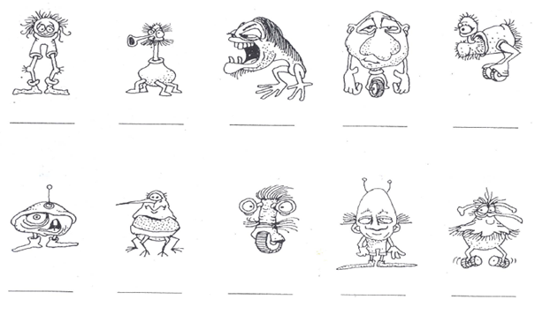

17. Classify the following living things   
  
a) Dog (1.5 marks)

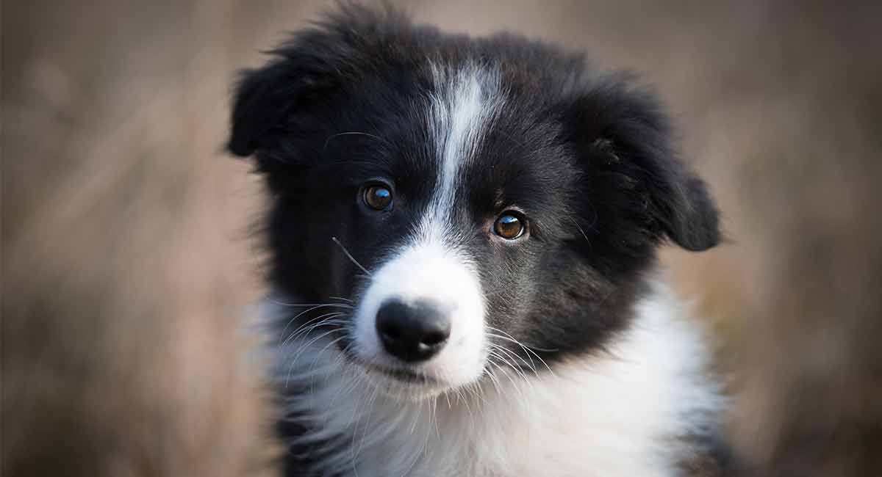

Kingdom  
  
_____________________________  
  
Phylum  
  
_____________________________  
  
Class  
  
_____________________________

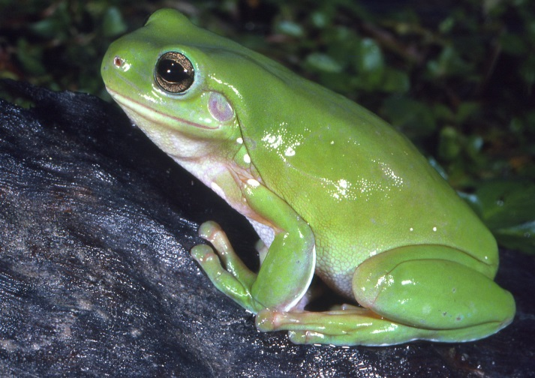b) Frog (1.5 marks)

Kingdom  
  
_____________________________  
  
Phylum  
  
_____________________________  
  
Class  
  
_____________________________

c) Turtle (1.5 marks)

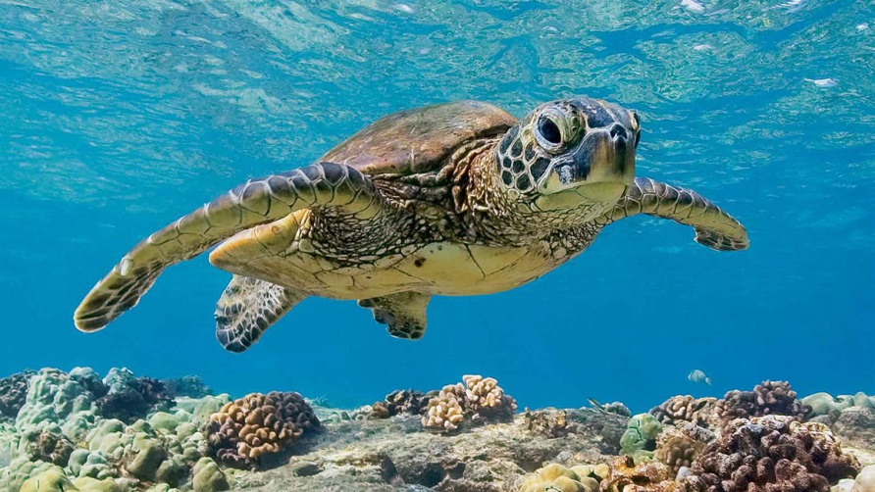

Kingdom  
  
___________________________  
  
Phylum  
  
___________________________  
  
Class  
  
___________________________

d) Snail (1 mark)

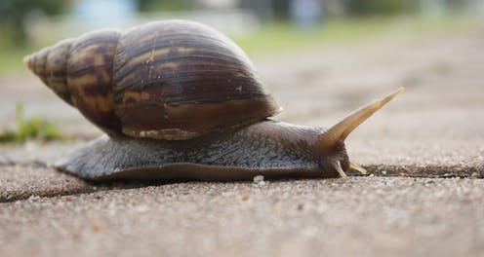   
Kingdom  
  
___________________________  
  
Phylum  
  
___________________________

e) Toadstool (0.5 mark)  
  
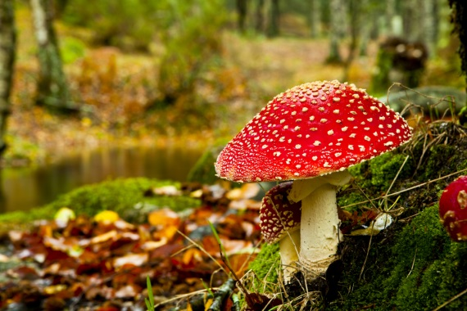Kingdom  
  
___________________________

f) Bacteria (0.5 marks)

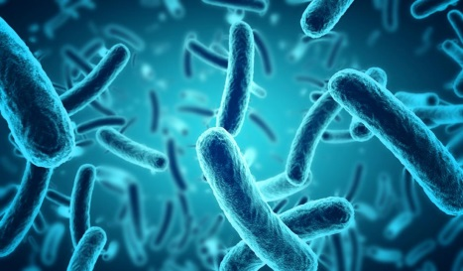

Kingdom  
  
___________________________

18. A crocodile is a living thing. (1.5 marks)

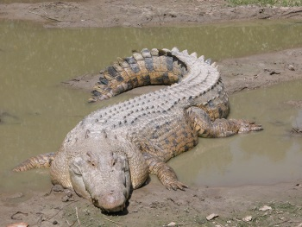Can you describe the features of a crocodile why they are classified as below?

Kingdom: Animalia  
Phylum: Chordata

Class: Reptile  
  
  
______________________________________________________________________________  
  
______________________________________________________________________________  
  
______________________________________________________________________________